Coral S. Schmidt Montilla #148830

Assignment 3.1

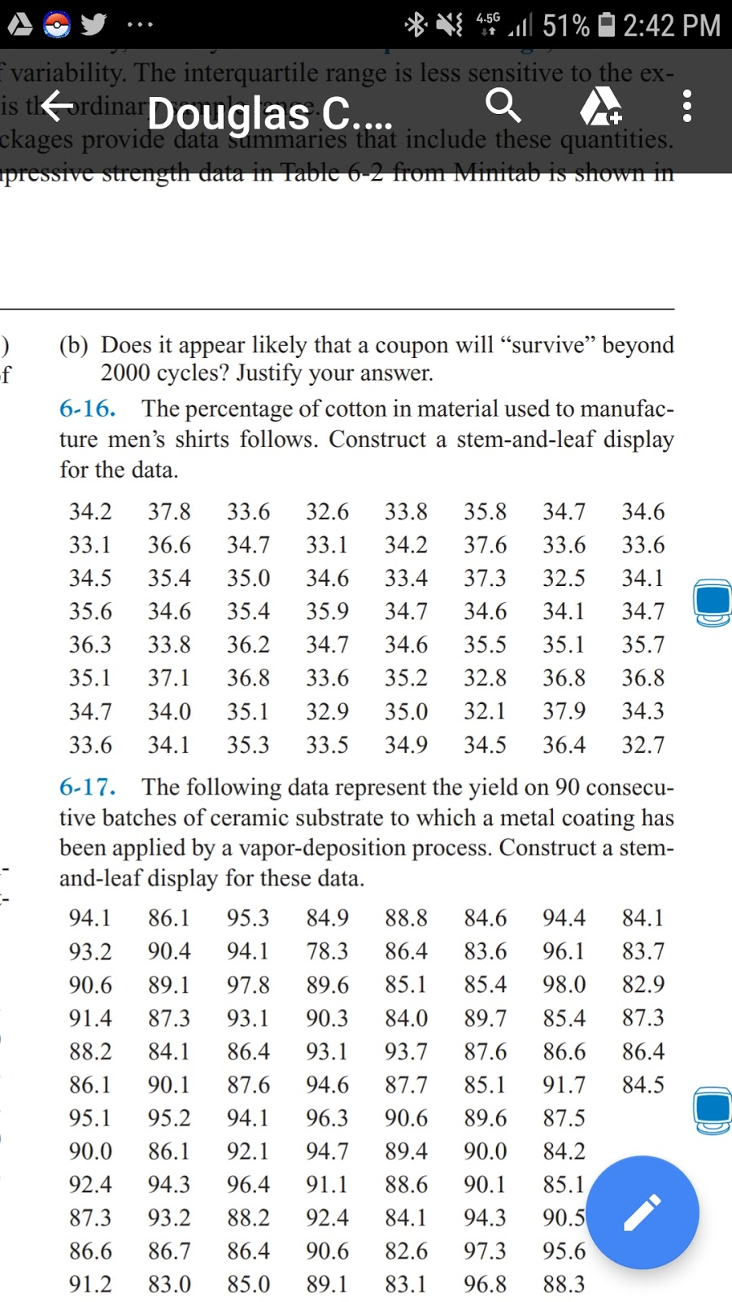



1. What is the sample mean?



1. What is the mode?



1. What is the median?



1. What is the third quartile?



1. Construct the Histogram.

